 | 28.2 Asset Browser – Essentials Asset Library
Table of content
Esential Asset Library 2
The Asset Browser 2
Library Contents 2
Introduction 3
The Asset Browser Library and Modifier assets 3
General functionality 3
Examples of properties: 4
Categories Overview 4
Simple Usage 4
Preparation 4
Loading Assets 5
Categories 6
Hair – Deformations 6
Blend Hair Curves 6
Frizz Hair Curves 6
Hair Curves Noise 6
Roll Hair Curves 6
Rotate Hair Curves 6
Shrinkwrap Hair Curves 6
Smooth Hair Curves 7
Hair – Generation 7
Duplicate Hair Curves 7
Generate Hair Curves 7
Interpolate Hair Curves 7
Hair – Guide 7
Braid Hair Curves 7
Clump Hair Curves 7
Create Guide Index Map 7
Curl Hair Curves 7
Hair – Read 8
Curve Info 8
Curve Root 8
Curve Segment 8
Curve Tip 8
Curve Attachment Info 8
Hair – Utility 8
Attach Hair Curves to Surface 8
Redistribute Curve Points 8
Restore Curve Segment Length 9
Hair – Write 9
Set Hair Curve Profile 9
Normals 9
Smooth by Angle 9

Essentials Asset Library

Bforartists comes with a default asset library created by Blender. This asset library is a special one that only allows to append assets, there is no way to link in the assets.
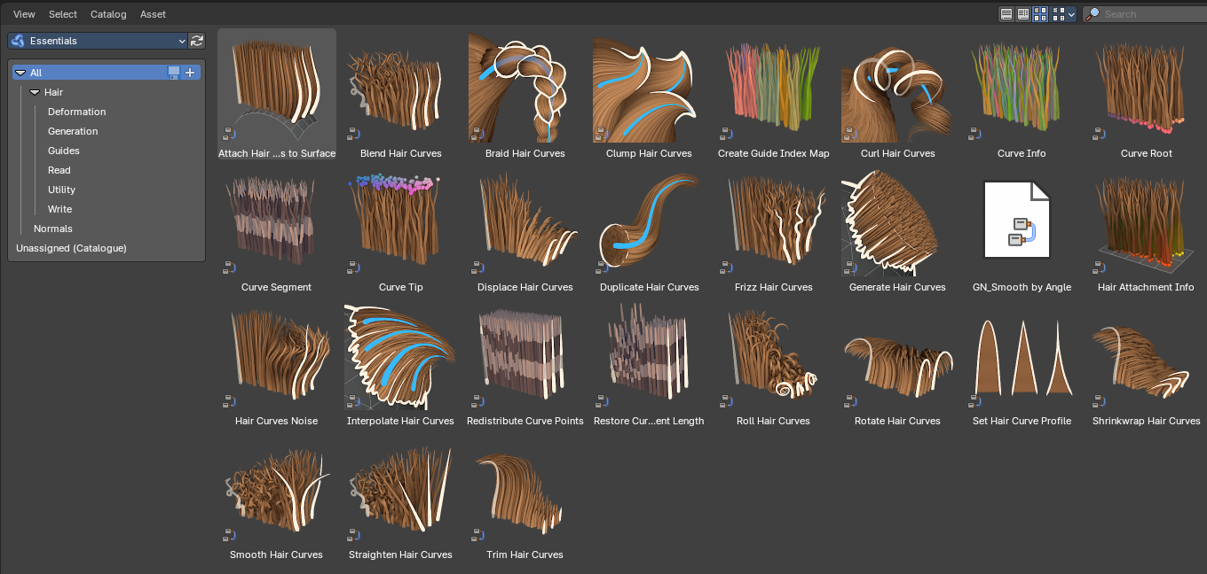

The Asset Browser
The Asset Browser is an editor in the Asset Workspace that gives you some essential nodegroups mostly for curves objects and curve data geometry nodes modifiers and node groups.

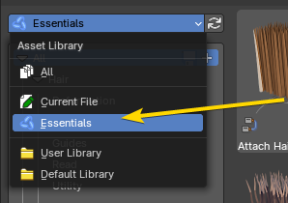
Library Contents
To select the Essential Library, choose it from drop-down box that contains the libraries that comes with Bforartists. Here you can select what asset you want to load.
The assets are grouped by categories.

Introduction

The Asset Browser Library and Modifier assets
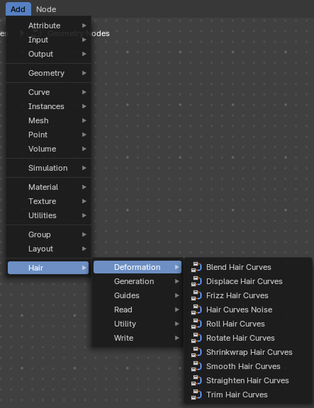
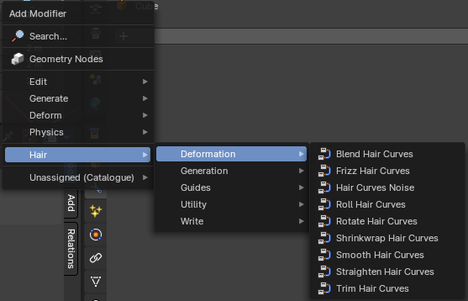

Hair nodes are Geometry node groups found in the Essentials Library included with Bforartists. They differ from the other nodes in the add menu due to being mid level node groups instead of individual low level nodes.
These hair nodes are also available as Modifier assets. When used as a Modifier asset, these adds the same node group as you would do it in the geometry node editor. Which means you can control these node groups in the modifier stack now instead of the geometry node editor.
Note: Curves objects is usually a mesh only functionality. But shows for all other object types too. You can use some of the these node groups with Curve data also.


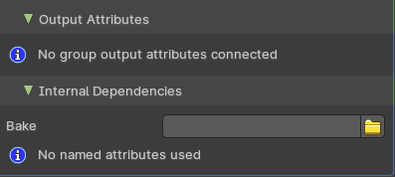
General functionality
Every node group has a set of parameters with tooltips, each can help you understand what each node group does. You can view the properties in the modifiers stack in the Properties Editor or directly in the Geometry Nodes Editor.
All node groups also have an Output Attributes and Internal dependencies tab. If the hair node has output attributes or internal dependencies depends of the hair node.

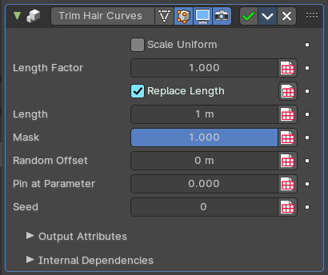
Examples of properties:
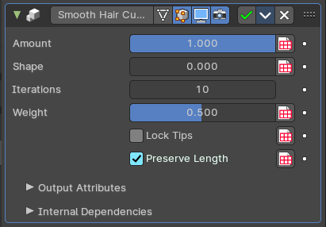
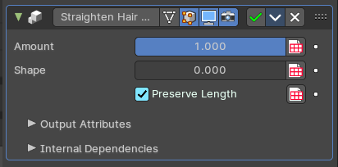

Categories Overview
- Hair
  - Deformers
  - Generation
  - Guides
  - Read
  - Utility
  - Write
- Normal

Usage

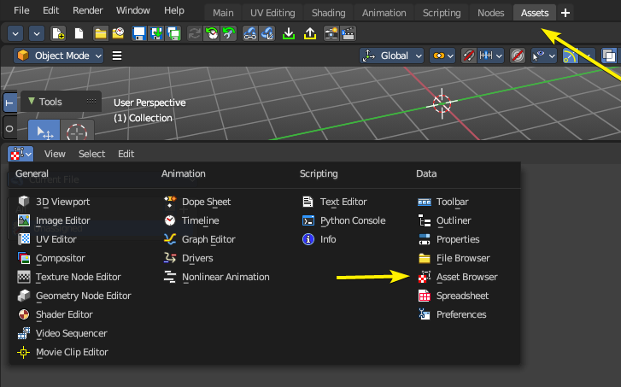
Preparation
Select the Assets Workspace or alternatively change and editor by toggling the Hide Editor Type and changing it to the Asset Browser.
Once you have an asset browser open, select the Default Library from the drop down to the top left of the editor.

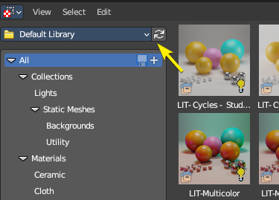
If you don’t see any assets, press the refresh icon.

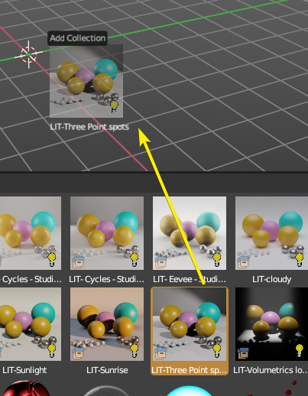
Loading Assets
Click on any categories in the left sidebar, then click and drag on an item to then add it into either the Node editors or the 3D View.

The asset and editor context may influence where you can drag and drop. Example: A collection can only be added to the 3D Viewport, but a Node Group can only be added to the Node Editor in the correct mode (Shader, Geometry Nodes, etc)

You can also drag and drop the assets onto data slots.
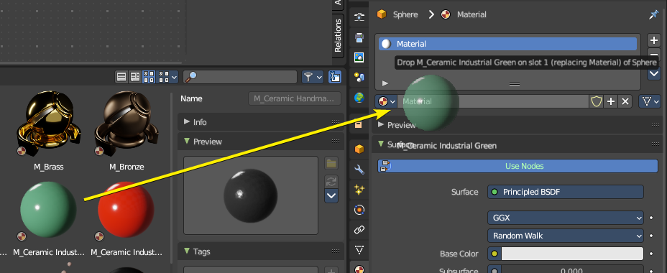

Categories

Brushes

Curve Sculpt

Grease Pencil Draw

Grease Pencil Draw

Grease Pencil Draw

Grease Pencil Draw

Mesh Sculpt

General

Add & Subtract

Contrast

Transform

Utilities

Paint

Simulation

Mesh Texture Paint

Mesh Vertex Paint

Mesh Weight Paint

Hair

Deformations
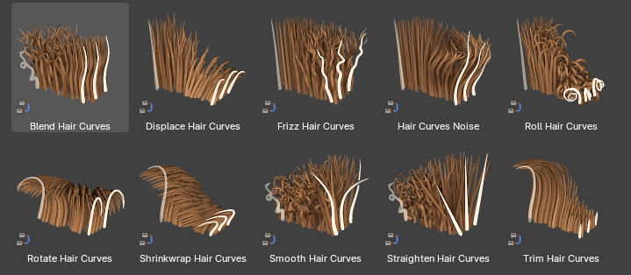
This group of hair node groups are useful for deforming the curves object hair strands. They can also be used on curve objects or curve data in other geometry nodes.

Blend Hair Curves
Blends the shape between multiple hair curves in a certain radius together.

Frizz Hair Curves
Deforms hair curves using a random vector per point to frizz them.

Hair Curves Noise
Deforms hair curves using noise texture.

Roll Hair Curves
Rolls up hair curves, starting from their tips.

Rotate Hair Curves
Rotates each hair curve around an axis.

Shrinkwrap Hair Curves
Shrinkwrap hair curves to a mesh surface from below and optionally from above.

Smooth Hair Curves
Smooths the shape of hair curves.

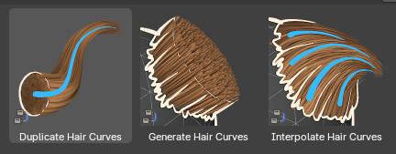
Generation
The curves object node groups contain methods to generate new hair strands.

Duplicate Hair Curves
Duplicates hair curves a certain amount of times in the given radius.

Generate Hair Curves
Generates new hair curves on a surface mesh.

Interpolate Hair Curves
Interpolates existing guide curves on a surface.

Guide
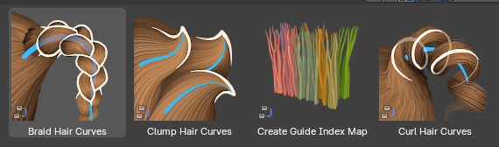

Braid Hair Curves
Deforms existing hair curves into braids using guide curves.

Clump Hair Curves
Clumps together existing hair curves using guide curves.

Create Guide Index Map
This creates a new index map as an attribute that maps each curve to its nearest guide via index to assist in using an index field per hair cluster.

Curl Hair Curves
Deform existing hair curves into curls.

Read
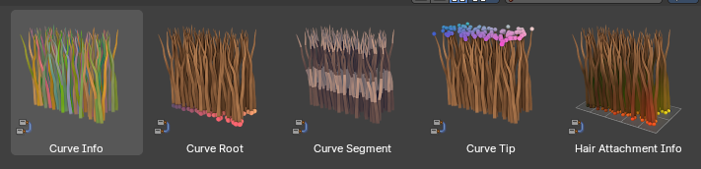

Curve Info
Reads and gets the individual curve data as a field, including the index, curve ID, length, direction, random and surface UV.

Curve Root
Reads information and gets data from every curve’s root point.

Curve Segment
Reads information from each point in from every curve’s previous curve segment.

Curve Tip
Reads information and gets data from every curve’s tip point.

Curve Attachment Info
Reads information and gets data from the attach point regarding a surface mesh.

Utility

Attach Hair Curves to Surface
Attaches hair curves to a surface mesh.
Note: Bare in mind you will need to parent the hair curves to a mesh before you can attach the curves to a surface mesh.

Redistribute Curve Points
Redistributes existing control points evenly along each curve.

Restore Curve Segment Length
Restore the length of each curve segment using a previous state after deformation. Consider this like a bypass node.

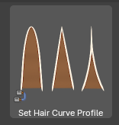
Write

Set Hair Curve Profile
Set the radius attribute of hair curves according to a profile shape.

Normals
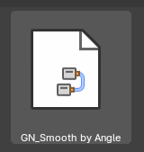
This category only contains one node for procedural autosmoothing of normals.

Smooth by Angle
Smooth normals by angle procedurally. Anything above a certain angle threshold will be marked as sharp.

